**

*S.G.G.P*

*JIJAMATA SENIOR COLLEGE*

*Jategaon Bk., Tal.- Shirur Dist.- Pune*

*Project Report*

*On*

***Online Examination System in PHP and MySQL***

*Submitted to*

BACHELOR INBSC COMPUTER SCIENCE

2023-24

By

Name: Rohan Thite Name: Priti Kalamkar

Roll No: 8008 Roll No: 8009

Under the Guidance of

Ms. Sarika S. Jedhe

Assistant Professor

**

*S.G.G.P*

*JIJAMATA SENIOR COLLEGE*

*Jategaon Bk., Tal.- Shirur Dist.- Pune*

*( Department of Computer Science )*

***CERTIFICATE***

*This is to certify that, the project report entitled* ***“Online Examination System”*** *which is submitted by* ***Rohan Suresh Thite & Priti Mohan Kalamkar*** *students of Shree Gurudatta Gramvikas Prathisthan’s Jijamata Senior College Jategaon Bk. in partial fulfillment of T.Y.B.Sc.(Computer Science) Project Work in academic year 2023-2024. They have satisfactorily completed the project work under our guidance and supervision. We wish our best wishes for your future endeavor.*

*Prof. Sarika Jedhe* *Prof.Sonali Awhale*

*( HOD,Computer Science ) ( Project guide )*

# ***ACKNOWLEDGEMENT***

*We convey our sincere gratitude to for giving us the opportunity to prepare our project work in online examination system. We express our sincere thanks to all the Staff members of department of computer.*

*We are thankful to Ms. Sarika Jedhe for his guidance during our project work and sparing his valuable time for the same.*

*We express our sincere obligation and thanks to the Principal and The Department of Computer Science, Shree Gurudatta Gramvikas Pratisthan Jijamata Senior College Jategaon BK., for providing us with guidance, help, motivation and valuable advice at every stage for completing the project work successfully.*

***INDEX***

|  |  |  |
| --- | --- | --- |
| ***Sr. No.*** | ***Content*** | ***Page No.*** |
|  | *Introduction* | *5* |
|  | *System Analysis* | *6* |
|  | *System Specifications* | *7* |
|  | *Feasibility Study* | *8* |
|  | *Advantages* | *9* |
|  | *Disadvantages* | *10* |
|  | *Future Scope* | *11* |
|  | *Data Flow Diagram* | *15* |
|  | *E-R Diagram* | *17* |
|  | *Testing* | *18* |
|  | *Database Table* | *21* |
|  | *Output Screenshots* | *30* |
|  | *Future Enhancement* | *31* |
|  | *Limitation of project* | *32* |
|  | *Conclusion* | *33* |
|  | *Bibliography* | *34* |

***Introduction***

*Online examinations are an important method of evaluating the success potential of students. This research effort the individuals under consideration were students who would be enrolling in computer courses or Technologies Registrations. A prototype of a web-based placement examination system is described from the standpoint of the research effort, end user, and software development.*

*Users enrolled in the platform may access the electronic details they provided and perform various functions with the on-line educational system in order to participate in the on-line examinations. Users can receive an on-line exam, having multimedia content, for the course, and they can electronically provide answers for the exam. And after Completion of their duration of exam they are provided the grade or marks secured in their examinations.*

***SYSTEM ANALYSIS :-***

***1. Existing System***

*Existing system is a manual one in which users are maintaining books to store the information like Student Details,Instructor Details,Schedule Details and feedbacks about students who attempted exam as per schedule.. It is very difficult to maintain historical data.*

***2. Proposed System***

*This application is used to conduct online examination. The students can sit at individual terminals and login to write the exam in the given duration. The questions have to be given to the students. This application will perform correction, display the result immediately and also store it in database. This application provides the administrator with a facility to add new exams. This application provides the Instructor add questions to the exam, modify questions in the exam in a particular exam. This application takes care of authentication of the administrator, Instructor as well as the student.*

***3. Objective of the System***

*The objective of the Online Examination Tool is to provide better information for the users of this system for better results for their maintainence in student examination schedule details and grading details.*

***System Specifications :-***

***Hardware Requirements:-***

* *Pentium-IV(Processor).*
* *256 MB Ram*
* *512 KB Cache Memory*
* *Hard disk 10 GB*
* *Microsoft Compatible 101 or more Key Board*

***Software Requirements: -***

* ***Operating System :*** *Windows*
* ***Web-Technology:*** *PHP*
* ***Front-End****: HTML,CSS,JAVASCRIPT*
* ***Back-End:*** *MySQL*
* ***Web Server:*** *Apache SERVER.*

***FEASIBILITY STUDY:***

*Feasibility study is conducted once the problem is clearly understood. Feasibility study is a high level capsule version of the entire system analysis and design process. The objective is to determine quickly at a minimum expense how to solve a problem. The purpose of feasibility is not to solve the problem but to determine if the problem is worth solving.*

***1. Economical Feasibility***

*The computerized system will help in automate the selection leading the profits and details of the organization. With this software, the machine and manpower utilization are expected to go up by 80-90% approximately.*

***2. Operational Feasibility***

*In this project, the management will know the details of each project where he may be presented and the data will be maintained as decentralized and if any inquires for that particular contract can be known as per their requirements and necessaries.*

***ADVANTAGES OF ONLINE EXMINATION SYSTEM:***

* *Online Examination System is a computerized system which gives instant results and also saves time.*
* *It fully automates the previous manual process of taking written exams.*
* *It is implemented by web based online examination software or through Intranet variance. It decreases the need of supervision during the exam is being examine or taken using web based Online Examination System gives a high level of clarity as opposite of traditional method. Most of Online Examination System gives the result and instantly.*
* *In high school, Online Examination System is able to reduce the workload of teachers by using automated test paper exams and marking schemes.*
* *Students can study independently for example at home or any place.*
* *The amount of time given at a particular question gives you the ability of “Quick Learning Quick Thinking.”*
* *The data in Online Examination System is regenerated repeatedly so that students have access to new data.*
* *In current scenario, because of COVID-19 we can use “online examination system”.*

***DISADVANTAGES OF ONLINE EXAMINATION SYSTEM:***

* *The question and answers may be tricky and confusing as there are multiple choices for answers.*

* *Lack of interaction between the teacher and student.*

* *Network problems may arise in Online Examination System, test may be postponed or cancel.*

* *As India is not a fully developed country problem may arise in rural areas where there is deficiency of computers or where computers are not yet discovered.*

* *Hackers can easily manage to achieve confidential data through fake online application or websites.*

* *While attempting online exams we can easily manage to open another window on existing computer.*

* *Teaching techniques of an instructor or teacher may vary from online exam questions.*

***FUTURE SCOPE OF ONLINE EXAMINATION SYSTEM:***

* *Online Examination System is widely used as compared to other exams. Online examination system can be used in private institutes as well as educational institution.*

* *It is user friendly web base application it can be used anywhere and anytime.*

* *The main purpose of the system is to efficiently evaluate the candidate thoroughly through a fully automated system that not only saves a lot of time but also gives fast result and saves paper.*

* *The faculty prepares the tests and question for each exam.*

* *The question are shuffled in a random order so that possibility for getting questions in the same order for the student how are beside, it is very less.*

***Data Flow Diagrams (DFD)***

* *DFD, Data flow diagrams are used to graphically represent the flow of data in a business information system. DFD describes the processes that are involved in a system to transfer data from the input to the file storage and reports generation.*
* *Data flow diagrams can be divided into logical and physical. The physical data flow diagram describes the implementation of the logical data flow.*
* *DFD graphically representing the functions, or processes, which capture, manipulate, store, and distribute data between a system and its environment and between components of a system. The visual representation makes it a good communication tool between User and System designer. Structure of DFD allows starting from a broad overview and expands it to a hierarchy of detailed diagrams.*
* *In Software engineering DFD (data flow diagram) can be drawn to represent the system of different levels of abstraction. Higher level DFDs are partitioned into low levels-hacking more*
* *Information and functional elements. Levels in DFD are numbered 0, 1, 2 or beyond. Here, we will see mainly 3 levels in data flow diagram, which are: 0-level DFD, 1-level DFD, and 2-level DFD.*

***Levels in Data Flow Diagrams (DFD)***

* ***0-level DFD:***

*It is also known as context diagram. It’s designed to be an abstraction view, showing the system as a single process with its relationship to external entities. It represents the entire system as single bubble with input and output data indicated by incoming/outgoing arrows.*

Online

Examination System

RESULT

S

ADMIN/

TEAC

HER

EXAMINATION

STUDENT

* ***1-level DFD:***

*In 1-level DFD, context diagram is decomposed into multiple bubbles/processes. in this level we highlight the main functions of the system and breakdown the high-level process of 0-level DFD into sub processes.*

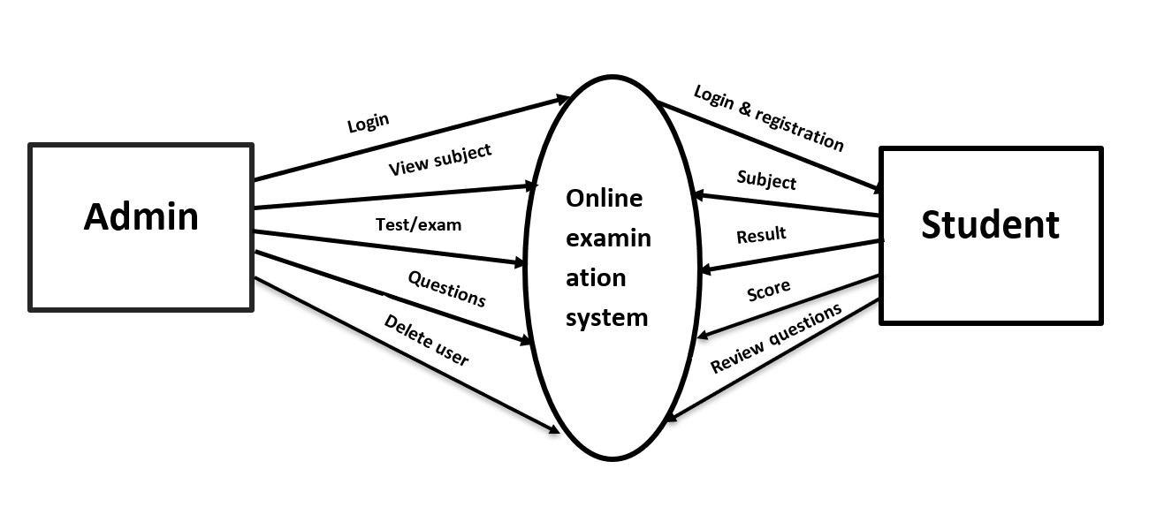

* ***2-level DFD:***

*2-level DFD goes one step deeper into parts of 1-level DFD. It can be used to plan or record the specific/necessary detail about the system’s functioning.*

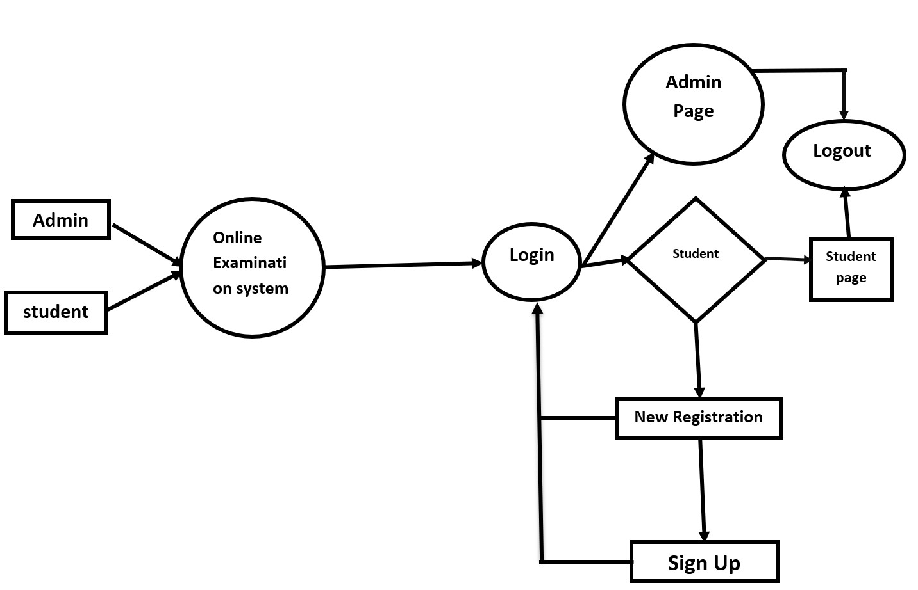

***ER Diagram***

*Entity relationship diagram displays the relationships of entity set stored in a database. In other words, we can say that ER diagrams help you to explain the logical structure of databases. At first look, an ER diagram looks very similar to the flowchart. However, ER Diagram includes many specialized symbols, and its meanings make this model unique.*

* ***Components of the ER Diagram***

*This model is based on three basic concepts: Entities, Attributes,*

*Relationships*

* ***ENTITY RELATIONAL (ER) MODEL***

*Is a high-level conceptual data model diagram. ER modeling helps us to analyze data requirements systematically to produce a well-designed database. The Entity-Relation model represents real-world entities and the relationship between them. It is considered a best practice to complete ER modeling before implementing one’s database.*

***ER Diagram of Online Examination System:-***

**Students**

**Admin**

Manages

Appears

Exam

has

Subjects

has

Questions

store

check

Marks

Answers

***TESTING:***

*The testing phase is an important part of software development. It is the puterized system will help in automate process of finding errors and missing operations and also a complete verification to determine whether the objectives are met and the user requirements are satisfied.*

*Software testing is carried out in three steps:*

*1.The first includes unit testing, where in each module is tested to provide its correctness, validity and also determine any missing operations and to verify whether the objectives have been met. Errors are noted down and corrected immediately. Unit testing is the important and major part of the project. So errors are rectified easily in particular module and program clarity is increased. In this project entire system is divided into several modules and is developed individually. So unit testing is conducted to individual modules.*

*2. The second step includes Integration testing. It need not be the case, the software whose modules when run individually and showing perfect results, will also show perfect results when run as a whole. A module can have inadvertent, adverse effect on any other or on the global data structures, causing serious problems*

*3.The final step involves validation and testing which determines which the software functions as the user expected. Here also some modifications were. In the completion of the project it is satisfied fully by the end user.*

***DATABASE TABLES:***

*USER REG TABLE*

|  |  |  |  |
| --- | --- | --- | --- |
| *NAME* | *NULL/NOTNULL* | *TYPE* | *KEY* |
| *ID* | *NOTNULL* | *INT* | *PRIMARYKEY* |
| *NAME* | *NULL* | *VARCHAR(50)* |  |
| *DOB* | *NULL* | *DATETIME* |  |
| *GENDER* | *NULL* | *VARCHAR(10)* |  |
| *BRANCH* | *NULL* | *VARCHAR(20)* |  |
| *COLLEGE* | *NULL* | *VARCHAR(50)* |  |
| *UID* | *NULL* | *VARCHAR(50)* |  |
| *PWD* | *NULL* | *VARCHAR(20)* |  |
| *RPWD* | *NULL* | *VARCHAR(20)* |  |
| *UTYPE* | *NULL* | *VARCHAR(20)* |  |
| *QUE* | *NULL* | *VARCHAR(500)* |  |
| *ANS* | *NULL* | *VARCHAR(500)* |  |

*True/False Based Question Table*

|  |  |  |  |
| --- | --- | --- | --- |
| *NAME* | *NULL/NOTNULL* | *TYPE* | *KEY* |
| *ID* | *NOTNULL* | *INT* | *PRIMARYKEY* |
| *QUE* | *NULL* | *VARCHAR(500)* |  |
| *AW* | *NULL* | *VARCHAR(500)* |  |

*True/False Based Answer Table*

|  |  |  |  |
| --- | --- | --- | --- |
| *NAME* | *NULL/NOTNULL* | *TYPE* | *KEY* |
| *ID* | *NOTNULL* | *INT* | *FOREIGNKEY* |
| *AW* | *NULL* | *VARCHAR(500)* |  |

*Options Based Question Table*

|  |  |  |  |
| --- | --- | --- | --- |
| *NAME* | *NULL/NOTNULL* | *TYPE* | *KEY* |
| *QID* | *NOTNULL* | *INT* | *PRIMARYKEY* |
| *QN* | *NULL* | *VARCHAR(500)* |  |
| *OPTIONS1* | *NULL* | *VARCHAR(100)* |  |
| *OPTIONS2* | *NULL* | *VARCHAR(100)* |  |
| *ANSWER* | *NULL* | *VARCHAR(100)* |  |

*Options Based Answers*

|  |  |  |  |
| --- | --- | --- | --- |
| *NAME* | *NULL/NOTNULL* | *TYPE* | *KEY* |
| *QID* | *NOTNULL* | *INT* | *FOREIGNKEY* |
| *ANSWER* | *NULL* | *VARCHAR(10)* |  |

*All Student Marks*

|  |  |  |  |
| --- | --- | --- | --- |
| *NAME* | *NULL/NOTNULL* | *TYPE* | *KEY* |
| *ID* | *NULL* | *INT* |  |
| *MARKS* | *NULL* | *INT* |  |

*Exam Schedule*

|  |  |  |  |
| --- | --- | --- | --- |
| *NAME* | *NULL/NOTNULL* | *TYPE* | *KEY* |
| *ENAME* | *NULL* | *VARCHAR(30)* |  |
| *EDATE* | *NULL* | *DATETIME* |  |

***Output Screenshots:-***

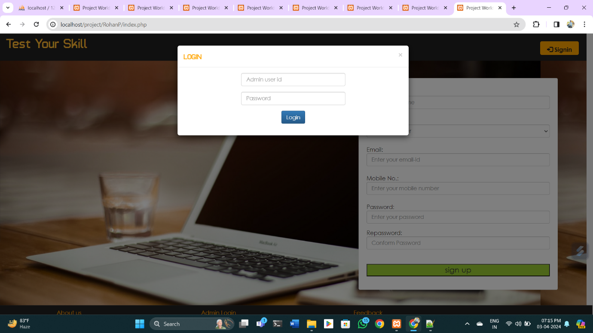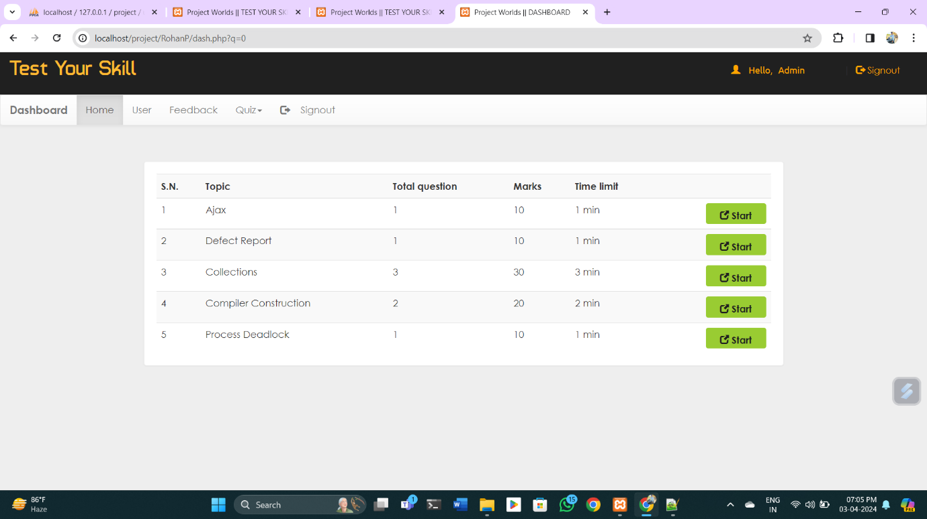

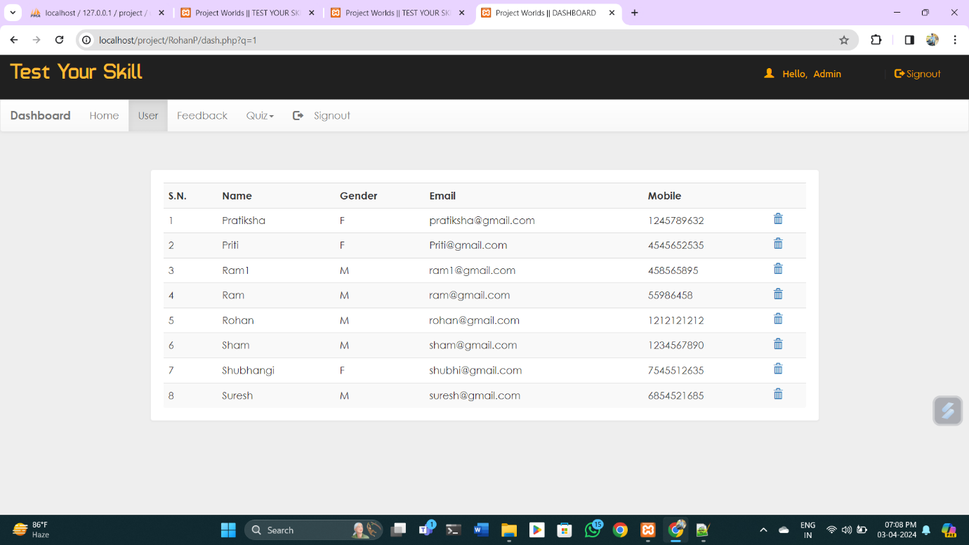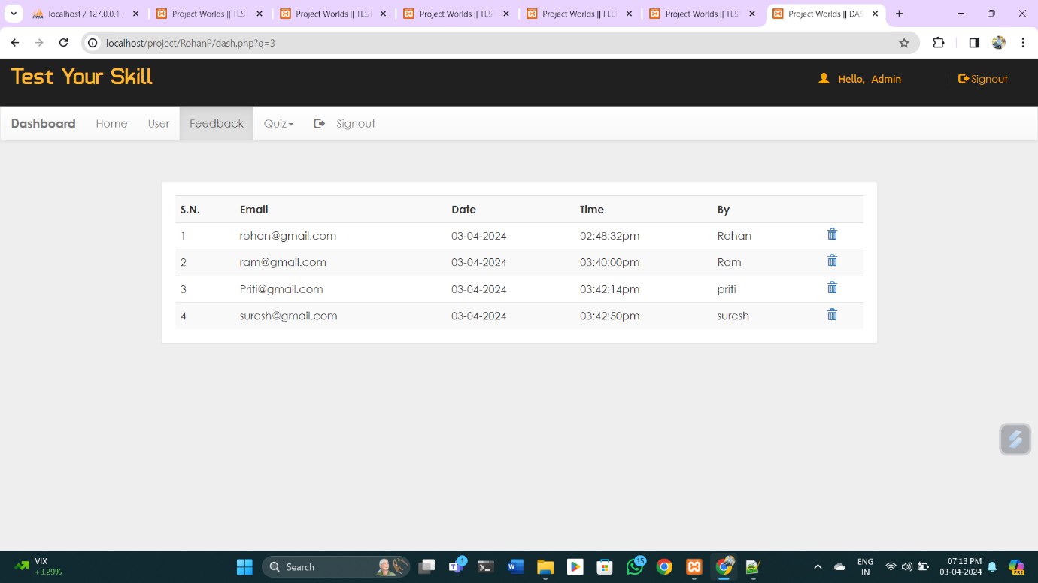

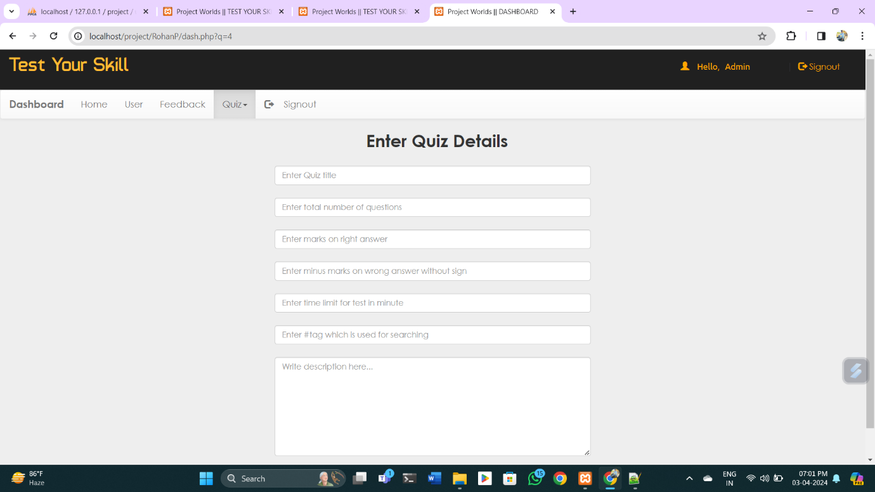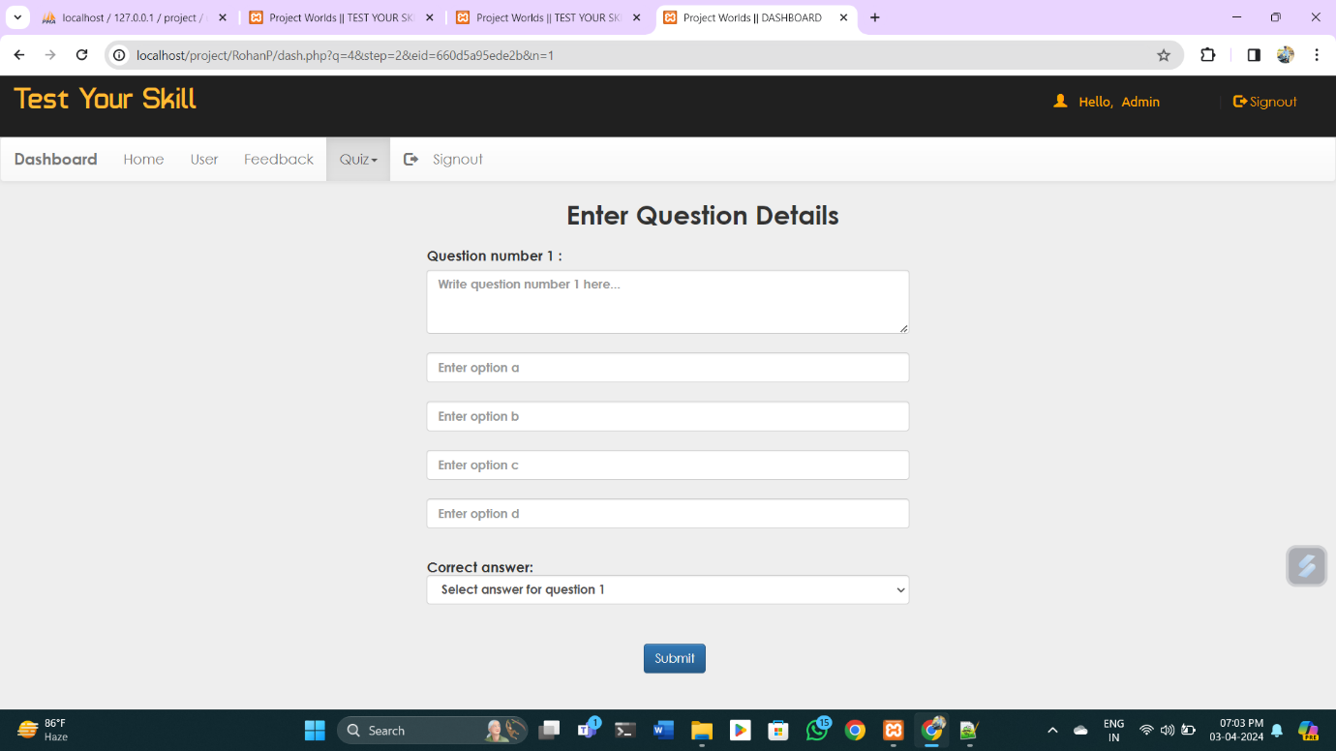

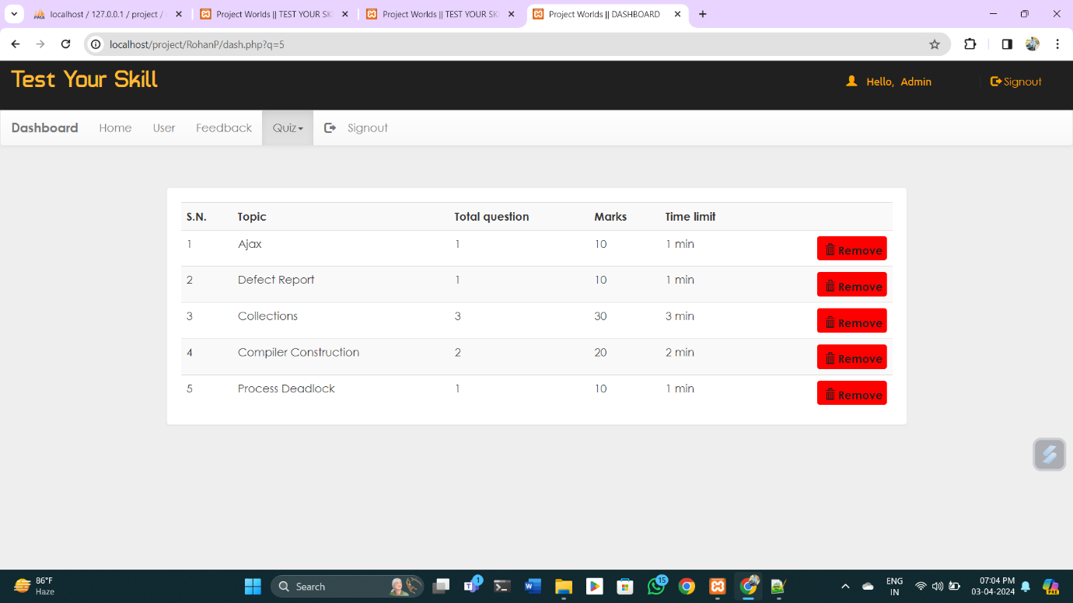

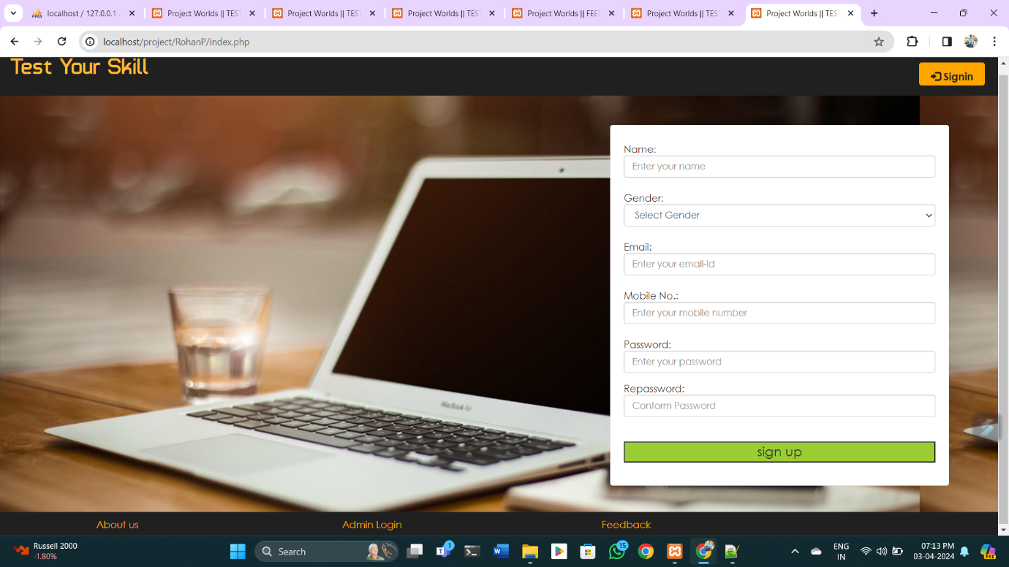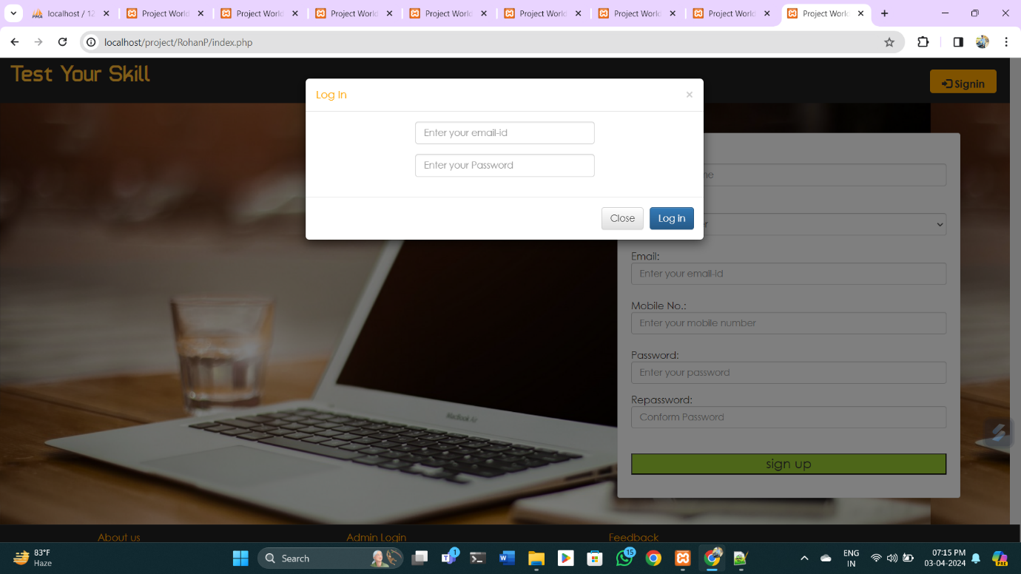

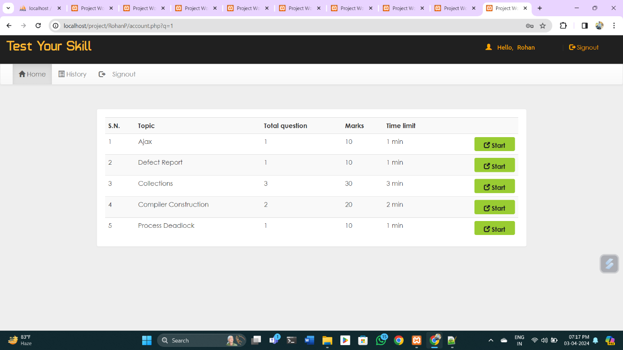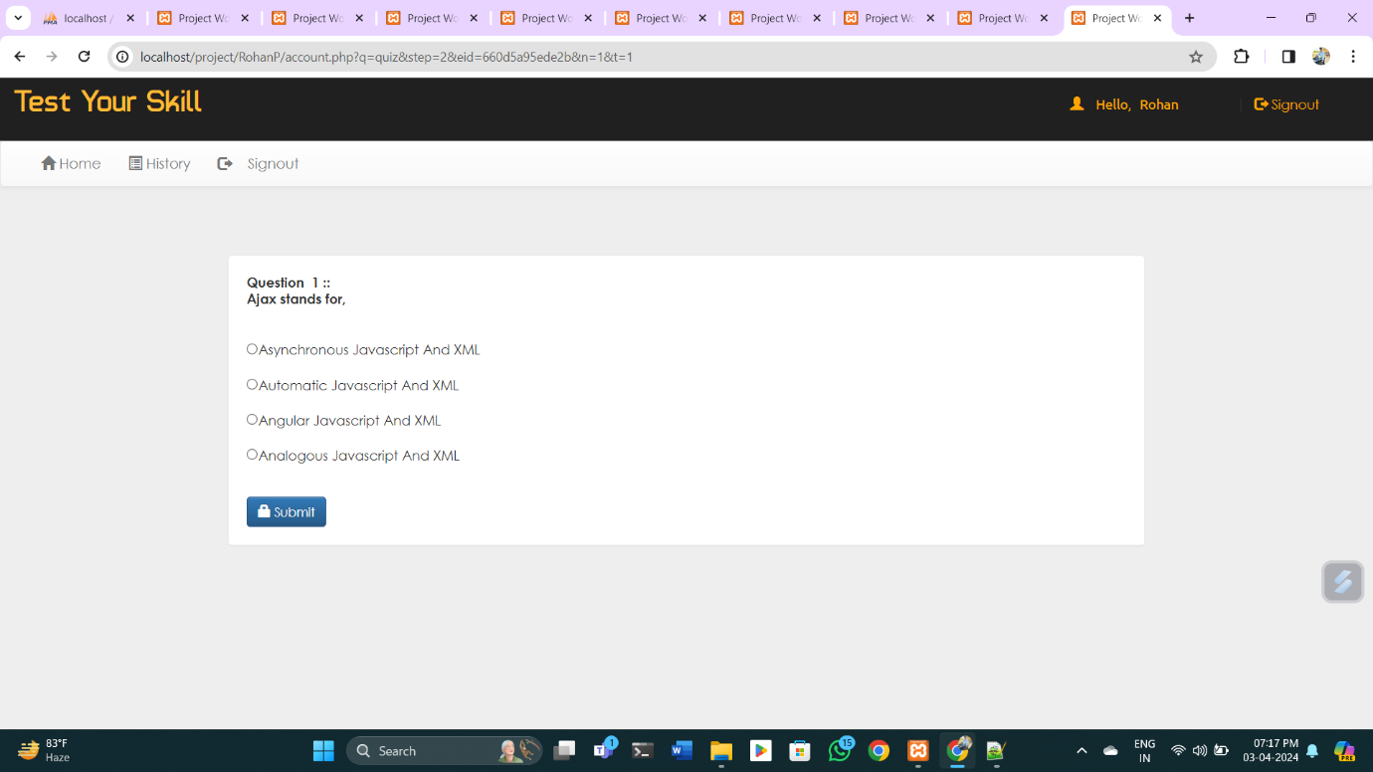

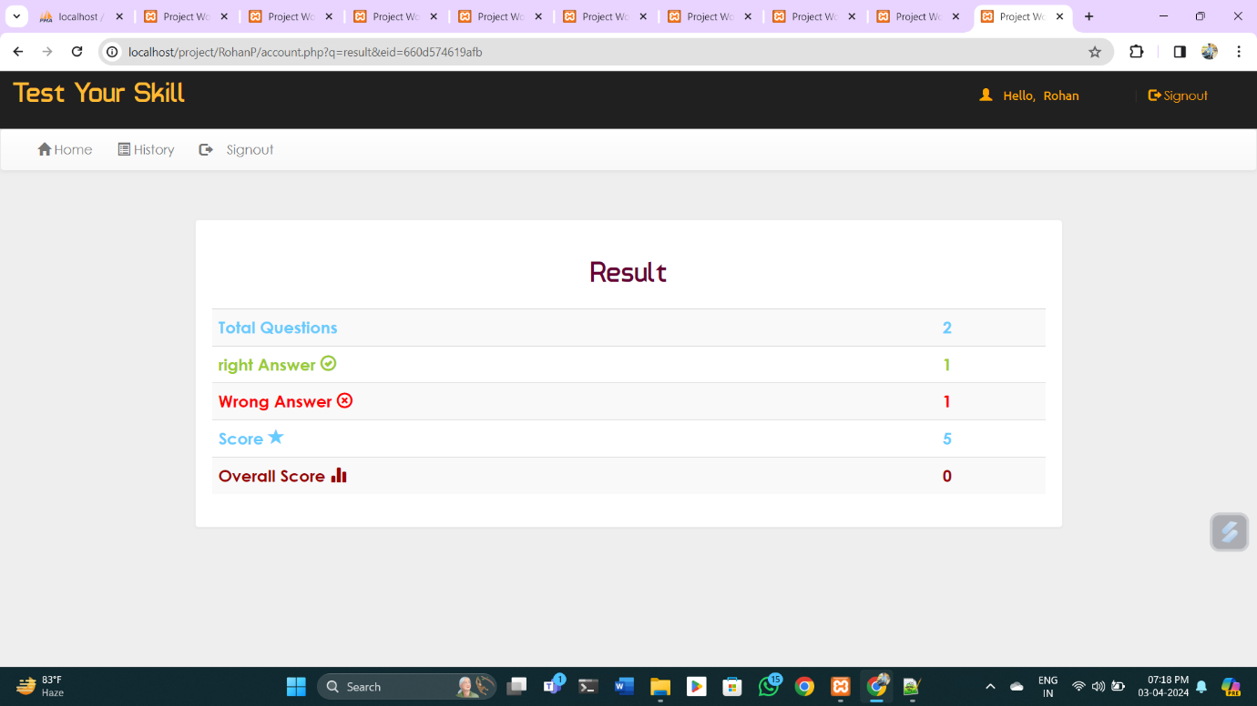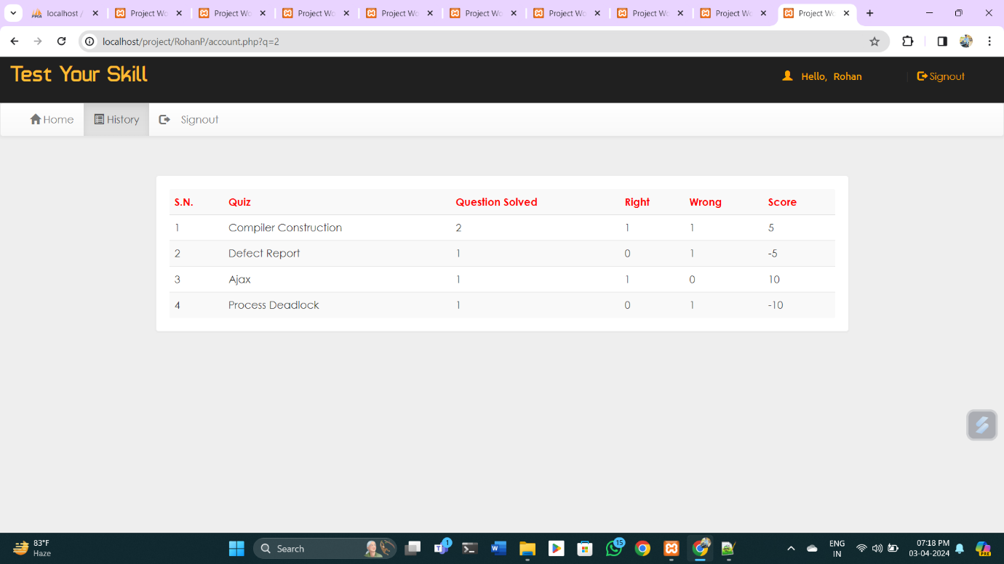

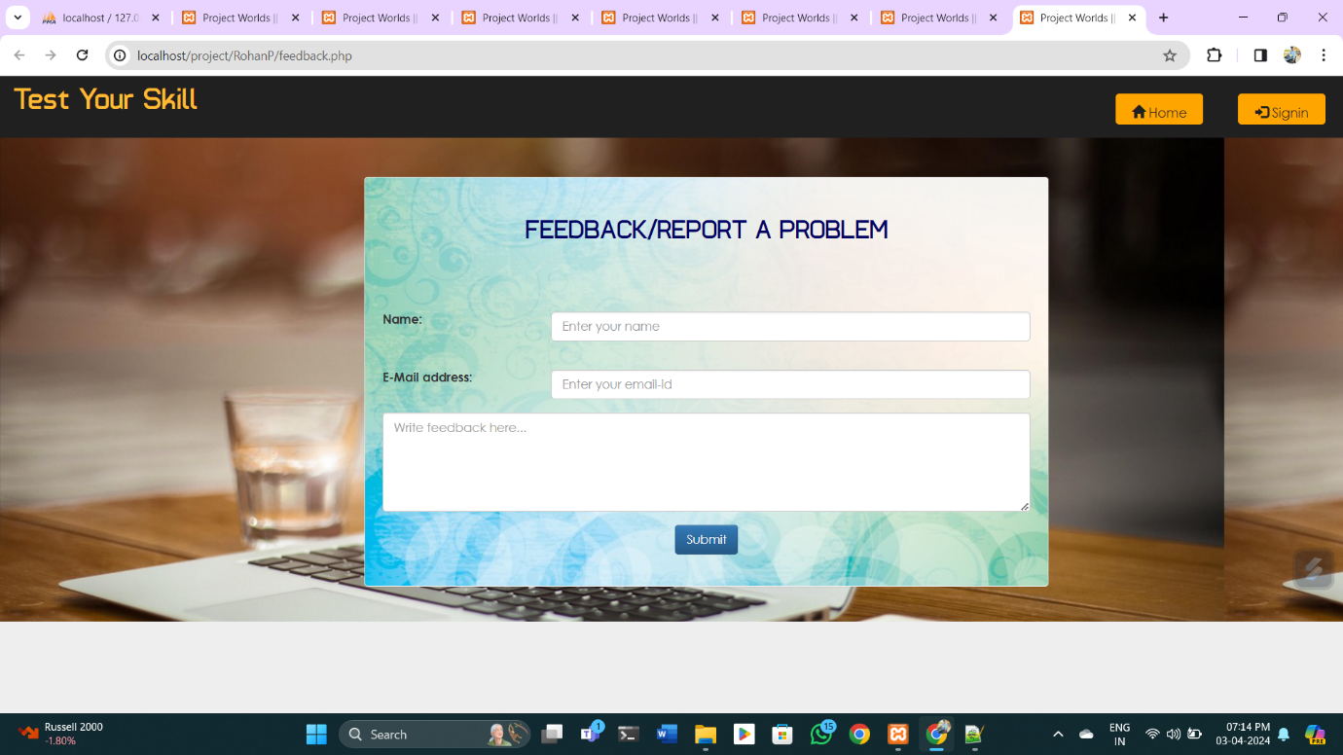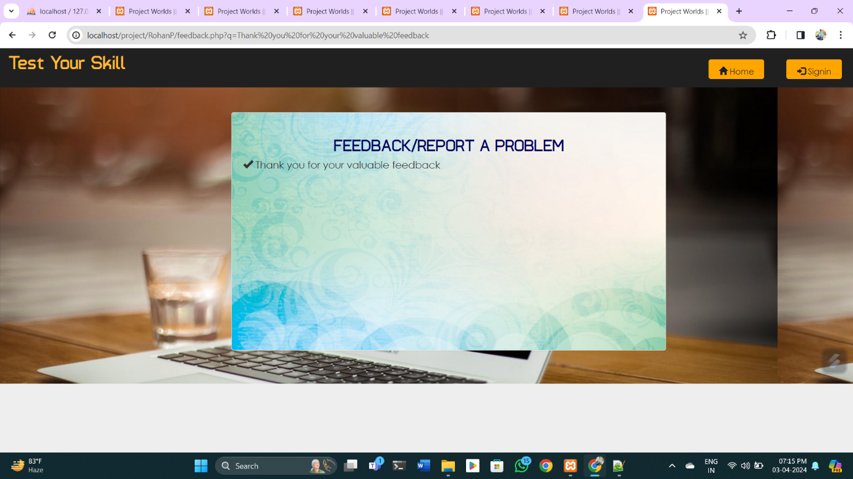

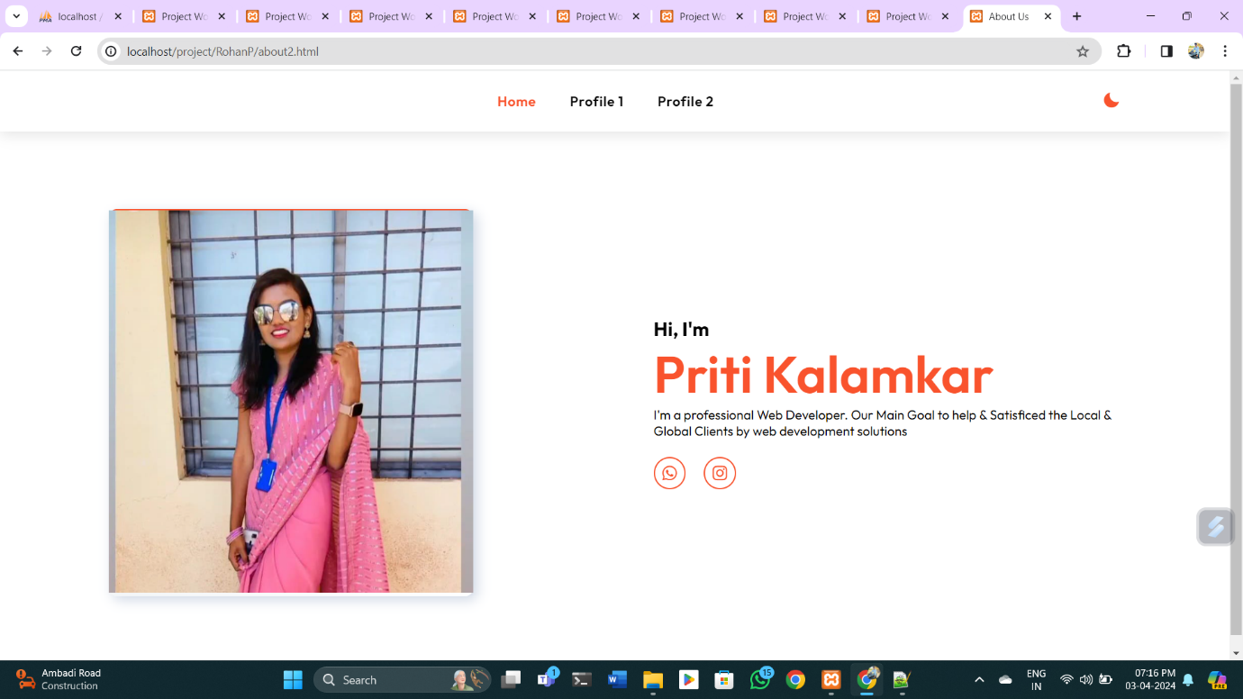

***FUTURE ENHANCEMENTS:***

*This application avoids the manual work and the problems concern with it. It is an easy way to obtain the information regarding the different scheduled examinations information that are*

*Currently issued.*

*Well I and my team members have worked hard in order to present an improved website better than the existing one’s regarding the information about the various activities. Still ,we found out that the project can be done in a better way. Primarily, when we request information about a particular schedules it just shows the exam date and platform. So, after getting the information we can get access to the onlineexam.*

*The enhancement that we can add the searching option. We can directly search to the particular student details from this site.*

***Limitation Of Project:***

* *In case of any type of problem in student verification no functionality is define in a system to correct it or intercommunication among user are also not available.*

* *Online examination system is restricted to multiple choice question which can be inefficient in assessing a student’s topic Mastery. Exams in the form of debates, essays, case-based questions and oral exams are difficult to conduct online.*

* *Online examination system does not support for adding images with question so questions containing diagram can not be saved in the system.*

* *It has no real existence in internet just tested on localhost.*

* *Skip of questions is not possible and the question is not displayed randomly.*

* *There is no negative marking and there is no fixed time and date for online exam, It can lead to excessive cheating.*

* *Not suitable for collaborative evaluations or group project.*

***CONCLUSION:-***

*The package was designed in such a way that future modifications can be done easily. The following conclusions can be deduced from the development of the project.*

* + *Automation of the entire system improves the efficiency*
  + *It provides a friendly graphical user interface which proves to be better when compared to the existing system.*
  + *It gives appropriate access to the authorized users depending on their permissions.*
  + *It effectively overcomes the delay in communications.*
  + *Updating of information becomes so easier.*
  + *System security, data security and reliability are the striking features.*
  + *The System has adequate scope for modification in future if it is necessary.*

**BIBLIOGRAPHY:**

* **Books Referred:**
* BEGINNING PHP 5 ---DAVE MERCER
* BLACK BOOK HTML ---WILEY DREAMTECH
* PHP AND MYSQL WEB DEVELOPMENT --- LUKEWELLING,LAURA
* MICROSOFT SQL SERVER-2000 ---RANKIN, PAUL & JENSEN
* SQL SERVER-2000 ---DUSAN PETKOVIC
* PHP IN A NUTSHELL --- PAUL HUDSON
* **Websites Referred:**

[Software Testing Tutorial - Tutorials point](https://www.tutorialspoint.com/software_testing/index.htm)

<https://www.geeksforgeeks.org/>

<https://www.w3schools.com/>

<https://programmer2programmer.net>

<https://projectworld.in>

<https://1000projects.org>

https://www.academia.edu